Smart Cradle Baby Monitoring System - Project Report

1. Abstract
The Smart Cradle Baby Monitoring System is an IoT-based intelligent system designed to enhance the quality of care for infants by supporting caregivers in monitoring vital comfort and safety indicators. It incorporates multiple sensors and actuators that detect crying, wetness, temperature, humidity, and motion. The system responds with actions like cradle rocking and fan activation and sends alerts to caregivers via a mobile application and an LCD screen. It uses the Arduino Uno for hardware control and the NodeMCU ESP8266 for Wi-Fi-based IoT communication.

2. Introduction
Infant care requires constant attention, especially when monitoring conditions like temperature, wetness, or crying. Manual monitoring can be stressful for caregivers. This Smart Cradle Baby Monitoring System offers an automated approach, ensuring real-time detection and response to a baby's needs. Integrating embedded systems and IoT technology, the solution provides alerts, remote control features, and environmental monitoring.

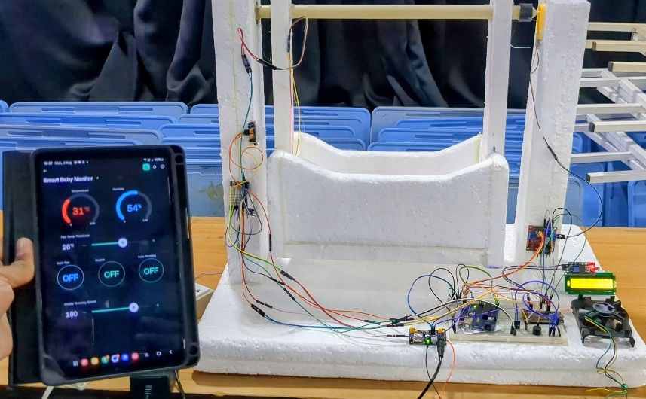
project sample photos
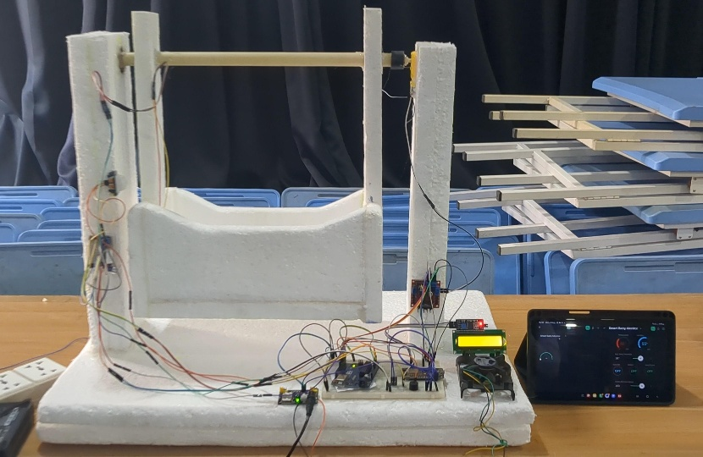

3. Objectives
- Monitor the baby’s crying, wetness, motion, temperature, and humidity.
- Auto-rock the cradle when crying or motion is detected.
- Activate fan based on a temperature threshold.
- Provide manual and remote control for fan, buzzer, and motor.
- Display data and alerts on a 16x2 LCD.
- Provide mobile-based interface via the Blynk IoT App.
- Use Serial Monitor for debugging and real-time logging.

4. System Architecture and Block Diagram
Components:
- Sensors: DHT22, PIR Motion Sensor, Sound Sensor, Wetness Sensor
- Actuators: DC Motor, Fan, Buzzer
- Microcontrollers: Arduino Uno, NodeMCU ESP8266
- Interface: 16x2 I2C LCD, Blynk App

Diagram: Block diagram showing sensors connected to Arduino, Arduino communicating with NodeMCU, and NodeMCU connected to LCD and Wi-Fi (Blynk App)
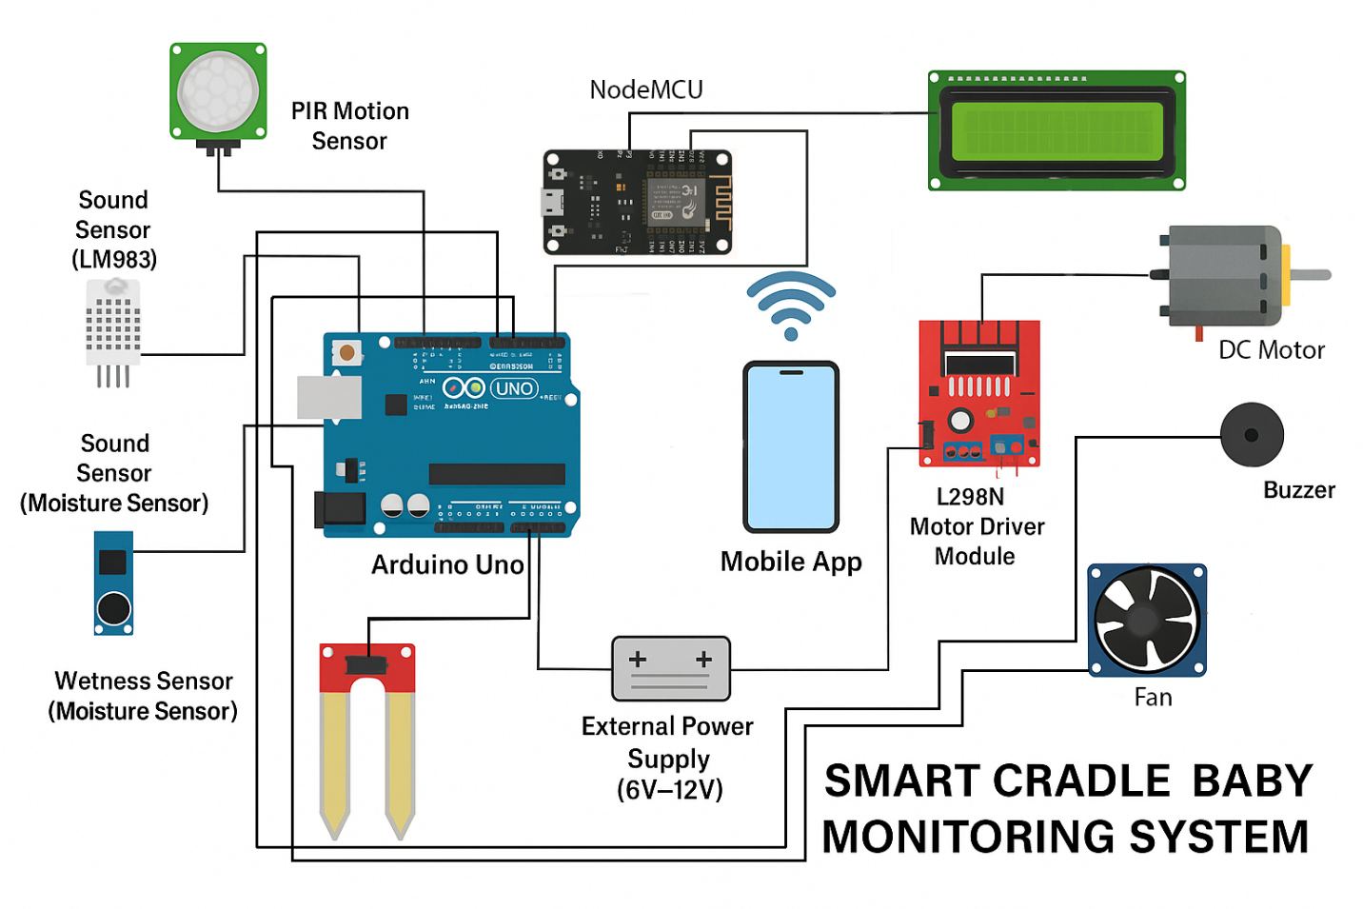

5. Components and Tools
Hardware:
- Arduino Uno
- NodeMCU ESP8266
- DHT22 Temperature & Humidity Sensor
- LM393 Sound Sensor
- Wetness Sensor (Moisture Sensor)
- PIR Motion Sensor
- L298N Motor Driver
- DC Motor
- Fan
- Buzzer
- 16x2 I2C LCD Display
- Power Supply (6V-12V)
Software:
- Arduino IDE
- Blynk IoT App (Android/iOS)
- Serial Monitor

6. Circuit Design and Wiring
6.1 Arduino Uno Wiring
- DHT22: Pin D2 (10k pull-up resistor)
- Sound Sensor OUT: A0 (VCC via D9)
- Wetness Sensor OUT: A1 (VCC via D10)
- PIR Motion Sensor: D3
- L298N Motor Driver: IN1-D4, IN2-D5, ENA-D6
- Fan: D7
- Buzzer: D8
6.2 NodeMCU Wiring
- Serial UART:
  - Arduino TX → NodeMCU RX (D3/GPIO0) via voltage divider
  - Arduino RX → NodeMCU TX (D4/GPIO2)
- I2C LCD:
  - SDA → D2 (GPIO4), SCL → D1 (GPIO5)
  - VCC → 5V, GND → GND

7. Software Implementation
7.1 Arduino Uno
- Sensor reading logic
- Rocking cradle motor control using PWM
- Fan and buzzer control
- Serial communication with NodeMCU
7.2 NodeMCU ESP8266
- Wi-Fi connectivity setup
- Blynk IoT control
- LCD screen updates
- Parses data from Arduino
- Sends commands from app to Arduino

8. Features and Virtual Pin Mapping (Blynk App)
Feature | Virtual Pin | Description
Rocking Speed | V1 | Adjust cradle speed (PWM)
Fan Control | V2 | Manual/auto toggle
Buzzer Alert Enable | V3 | Enable/disable buzzer
Temperature Reading | V4 | Real-time temperature
Humidity Reading | V5 | Real-time humidity
Wetness Level | V6 | Wetness sensor percentage
Temp Threshold | V7 | Temperature for auto fan activation
Auto-Rocking Enable | V8 | Toggle automatic cradle rocking
Cry Detection | V9 | Crying status from sound changes
Wet Detection | V10 | Boolean wetness status
Sound Level | V11 | Ambient noise level
Motion Detection | V12 | PIR detection status
Motor Speed Feedback | V13 | Real-time rocking speed
Fan Status | V14 | Fan ON/OFF status
Buzzer Status | V15 | Buzzer ON/OFF status

9. Detection and Control Logic
Cry Detection:
- Establish ambient sound baseline.
- Detect 20%+ sudden increase.
- Trigger rocking if cry and auto-mode are enabled.
Wetness Detection:
- Reverse analog reading from moisture sensor.
- Convert to percentage (1023 dry → 0 wet).
- Alert if above threshold.
Rocking Logic:
- PWM motor control for smooth rocking.
- Alternate directions periodically.
- Stop after 30s of no cry or motion.
Fan Logic:
- Manual: Toggle via Blynk V2.
- Auto: Fan ON if temp > V7 threshold.

10. LCD Display Screens
The LCD cycles through the following data:
- Temperature & Humidity
- Wetness & Sound Level
- Fan Status & Motor Speed
- Alerts: Cry Detected, Wet Alert, Motion Detected
LCD screen sample layouts
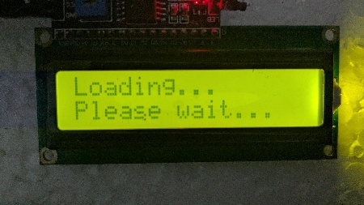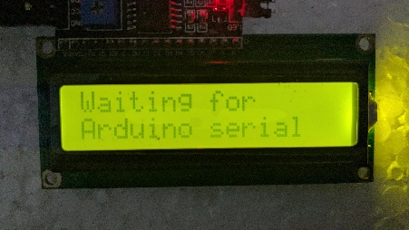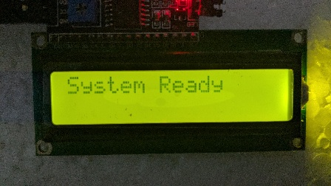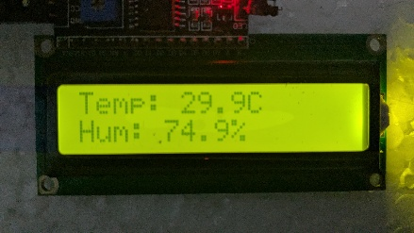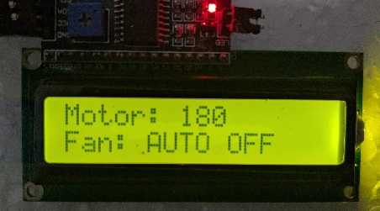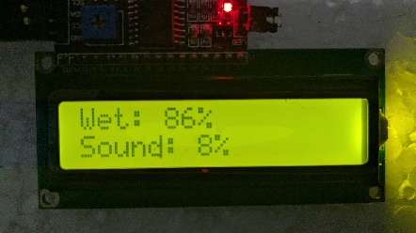
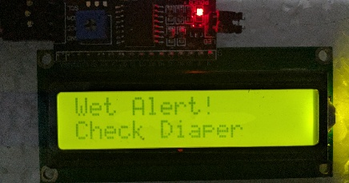

11. System Initialization Process
- Boot sequence:
  - "System Starting"
  - "Loading Sensors"
  - "Ready"
- NodeMCU connects to Wi-Fi.
- Sensors start sending data.
- LCD and Serial Monitor begin updates.

12. Safety Considerations
- Smooth motor transitions protect infant safety.
- Fan and buzzer are limited to safe durations.
- Noise detection includes delay buffers to avoid false alarms.
- NodeMCU input protected via voltage divider on RX pin.

13. Conclusion
The Smart Cradle Baby Monitoring System successfully integrates IoT and embedded technologies to automate critical aspects of baby care. It allows remote monitoring, environmental adjustments, and real-time alerts, reducing caregiver burden. Future upgrades could include camera integration, AI-based cry classification, and cloud-based data logging.

14. References
- Blynk IoT Platform: https://blynk.io
- ESP8266 Docs: https://arduino-esp8266.readthedocs.io
- Arduino Reference: https://www.arduino.cc/reference/en
- DHT22 Sensor Info: https://learn.adafruit.com/dht
- LM393 Sound Sensor: https://components101.com

[Team Members]
T.S.Balasooriya - 21ug0906
S.A.T.D.Bandara - 21UG0996
W.V.Tharaka Ruksal Wanigasekara - 21UG1125
R.P. Dinisuru Maduhansa -21UG1063

